1. Сортировка слиянием.

Начало: 17:13:09.535

Завершение: 17:13:09.624.

2. Сортировка методом вставки.

Начало: 17:14:19.131

Завершение: 17:14:24.231.

3. Сортировка пузырьком.

Начало: 17:16:09.597

Завершение: 17:17:48.001.

Программа запущена с параметрами -XX:+UseZGC -Xmx24m -Xms12m -Xlog:gc:log.txt

Видно, что задачи выполняются гораздо быстрее, чем это было с другими сборщиками.

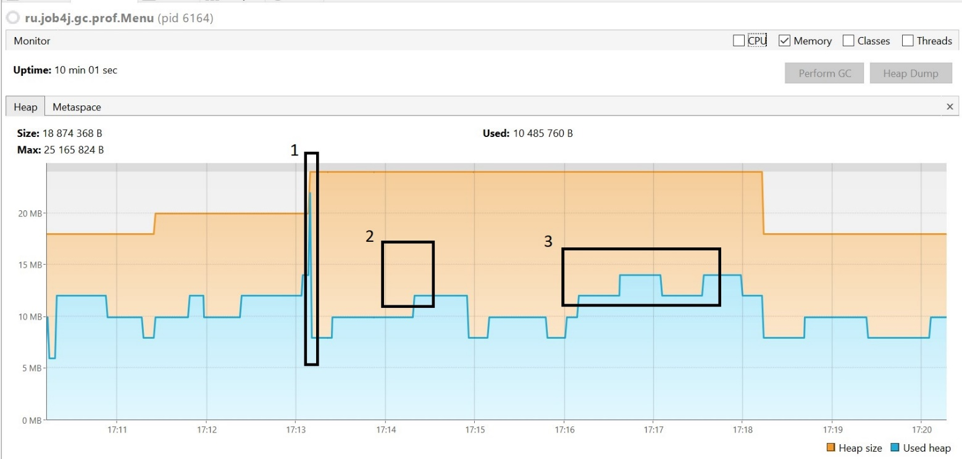

Фаза 1: сортировка слиянием нашла отражение на графике в виде вертикального подъема, обозначив максимальное значение на всем протяжении выполнения программы.

После завершения сортировки произошла сборка мусора.

Фаза 2: сортировка методом вставки никак не отразилась на графике – вертикальный подъем с 10Мб до 12Мб был произведен до сортировки. После завершения сортировки используемый размер оставался неизменным, почти 20 секунд, далее произошла сборка мусора.

Фаза 3: сортировка пузырьком увеличивала используемый размер кучи, но всего примерно на 2Мб.

После завершения сортировок график пришел в равновесие.

Также, на графике видно, как максимальный размер кучи подстраивается под потребности, как в сторону увеличения, так и в сторону уменьшения размера.

Файл log.txt

[0.012s][info][gc] Using The Z Garbage Collector

[0.163s][info][gc] GC(0) Garbage Collection (Warmup) 4M(17%)->2M(8%)

[5.558s][info][gc] GC(1) Garbage Collection (Warmup) 6M(25%)->6M(25%)

[5.650s][info][gc] GC(2) Garbage Collection (Warmup) 10M(42%)->8M(33%)

[5.762s][info][gc] GC(3) Garbage Collection (Allocation Rate) 16M(67%)->6M(25%)

[5.958s][info][gc] GC(4) Garbage Collection (Allocation Rate) 10M(42%)->8M(33%)

[6.057s][info][gc] GC(5) Garbage Collection (Allocation Rate) 8M(33%)->8M(33%)

[6.171s][info][gc] GC(6) Garbage Collection (Allocation Rate) 10M(42%)->8M(33%)

[6.258s][info][gc] GC(7) Garbage Collection (Allocation Rate) 8M(33%)->6M(25%)

[6.351s][info][gc] GC(8) Garbage Collection (Allocation Rate) 8M(33%)->6M(25%)

[11.151s][info][gc] GC(9) Garbage Collection (Proactive) 10M(42%)->10M(42%)

[34.153s][info][gc] GC(10) Garbage Collection (Proactive) 14M(58%)->8M(33%)

[45.165s][info][gc] GC(11) Garbage Collection (Proactive) 12M(50%)->6M(25%)

[57.168s][info][gc] GC(12) Garbage Collection (Proactive) 10M(42%)->6M(25%)

[69.158s][info][gc] GC(13) Garbage Collection (Proactive) 10M(42%)->6M(25%)

[77.263s][info][gc] GC(14) Garbage Collection (Proactive) 10M(42%)->10M(42%)

[100.252s][info][gc] GC(15) Garbage Collection (Proactive) 14M(58%)->8M(33%)

[110.253s][info][gc] GC(16) Garbage Collection (Proactive) 12M(50%)->10M(42%)

[135.262s][info][gc] GC(17) Garbage Collection (Proactive) 14M(58%)->10M(42%)

[162.252s][info][gc] GC(18) Garbage Collection (Proactive) 14M(58%)->8M(33%)

[176.267s][info][gc] GC(19) Garbage Collection (Proactive) 12M(50%)->10M(42%)

[182.134s][info][gc] Allocation Stall (main) 17.449ms

[182.137s][info][gc] GC(20) Garbage Collection (Allocation Stall) 24M(100%)->14M(58%)

[182.164s][info][gc] Allocation Stall (main) 16.272ms

[182.164s][info][gc] GC(21) Garbage Collection (Allocation Stall) 24M(100%)->14M(58%)

[182.260s][info][gc] GC(22) Garbage Collection (Allocation Rate) 20M(83%)->8M(33%)

[182.354s][info][gc] GC(23) Garbage Collection (Allocation Rate) 8M(33%)->8M(33%)

[182.464s][info][gc] GC(24) Garbage Collection (Allocation Rate) 8M(33%)->8M(33%)

[182.559s][info][gc] GC(25) Garbage Collection (Allocation Rate) 8M(33%)->8M(33%)

[182.651s][info][gc] GC(26) Garbage Collection (Allocation Rate) 8M(33%)->8M(33%)

[182.764s][info][gc] GC(27) Garbage Collection (Allocation Rate) 8M(33%)->8M(33%)

[182.859s][info][gc] GC(28) Garbage Collection (Allocation Rate) 8M(33%)->8M(33%)

[183.350s][info][gc] GC(29) Garbage Collection (Allocation Rate) 10M(42%)->8M(33%)

[183.460s][info][gc] GC(30) Garbage Collection (Allocation Rate) 8M(33%)->8M(33%)

[183.553s][info][gc] GC(31) Garbage Collection (Allocation Rate) 8M(33%)->8M(33%)

[183.661s][info][gc] GC(32) Garbage Collection (Allocation Rate) 8M(33%)->8M(33%)

[183.755s][info][gc] GC(33) Garbage Collection (Allocation Rate) 8M(33%)->8M(33%)

[183.863s][info][gc] GC(34) Garbage Collection (Allocation Rate) 8M(33%)->8M(33%)

[196.261s][info][gc] GC(35) Garbage Collection (Proactive) 12M(50%)->8M(33%)

[209.366s][info][gc] GC(36) Garbage Collection (Proactive) 12M(50%)->8M(33%)

[222.350s][info][gc] GC(37) Garbage Collection (Proactive) 12M(50%)->8M(33%)

[234.365s][info][gc] GC(38) Garbage Collection (Proactive) 12M(50%)->8M(33%)

[247.353s][info][gc] GC(39) Garbage Collection (Proactive) 12M(50%)->8M(33%)

[251.762s][info][gc] GC(40) Garbage Collection (Proactive) 12M(50%)->12M(50%)

[274.361s][info][gc] GC(41) Garbage Collection (Proactive) 16M(67%)->8M(33%)

[287.350s][info][gc] GC(42) Garbage Collection (Proactive) 12M(50%)->8M(33%)

[301.357s][info][gc] GC(43) Garbage Collection (Proactive) 12M(50%)->8M(33%)

[313.351s][info][gc] GC(44) Garbage Collection (Proactive) 12M(50%)->8M(33%)

[326.354s][info][gc] GC(45) Garbage Collection (Proactive) 12M(50%)->8M(33%)

[340.354s][info][gc] GC(46) Garbage Collection (Proactive) 12M(50%)->8M(33%)

[353.461s][info][gc] GC(47) Garbage Collection (Proactive) 12M(50%)->8M(33%)

[362.168s][info][gc] GC(48) Garbage Collection (Proactive) 12M(50%)->12M(50%)

[389.456s][info][gc] GC(49) Garbage Collection (Proactive) 16M(67%)->12M(50%)

[417.456s][info][gc] GC(50) Garbage Collection (Proactive) 16M(67%)->12M(50%)

[445.464s][info][gc] GC(51) Garbage Collection (Proactive) 16M(67%)->12M(50%)

[471.555s][info][gc] GC(52) Garbage Collection (Proactive) 16M(67%)->8M(33%)

[485.562s][info][gc] GC(53) Garbage Collection (Proactive) 12M(50%)->8M(33%)

[499.553s][info][gc] GC(54) Garbage Collection (Proactive) 12M(50%)->8M(33%)

[513.556s][info][gc] GC(55) Garbage Collection (Proactive) 12M(50%)->8M(33%)

[527.566s][info][gc] GC(56) Garbage Collection (Proactive) 12M(50%)->8M(33%)

[541.556s][info][gc] GC(57) Garbage Collection (Proactive) 12M(50%)->8M(33%)

[555.665s][info][gc] GC(58) Garbage Collection (Proactive) 12M(50%)->8M(33%)

[569.660s][info][gc] GC(59) Garbage Collection (Proactive) 12M(50%)->8M(33%)

[583.652s][info][gc] GC(60) Garbage Collection (Proactive) 12M(50%)->8M(33%)

[597.656s][info][gc] GC(61) Garbage Collection (Proactive) 12M(50%)->8M(33%)